# **Part 2: Elementary Data Structures Implementation & Discussion**

**Name: Pawan Pandey**

[ppandey29200@ucumberlands.edu](mailto:ppandey29200@ucumberlands.edu)

**University of Cumberlands**

**Course Number:** MSCS-532-B01

**Course Title:** Algorithms and Data Structures

**Instructor:** Dr. Vanessa Cooper

Nov 22 2024

## **Overview**

This report explores the design, implementation, and analysis of fundamental data structures: arrays, stacks, queues, and linked lists. By examining these structures, we gain a deeper understanding of their time complexities, trade-offs, and practical applications. This analysis helps in identifying the optimal data structure for specific scenarios.

## **Implementation**

### **Arrays**

An array is a collection of elements organized in consecutive memory locations, with a fixed size determined at creation. The implementation includes operations such as inserting a value at a specified index, deleting a value from a given index, and accessing elements. Arrays are ideal for tasks where indexed access is crucial due to their O(1) time complexity for direct access.

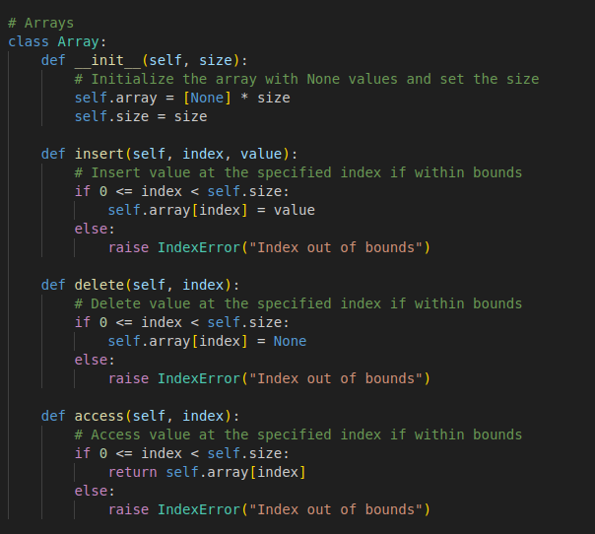

### **Stack**

A stack operates on the Last-In-First-Out (LIFO) concept, meaning the most recently added element is the first to be removed. The stack implementation allows for pushing elements onto the stack, popping elements off, and peeking at the topmost element. These operations are implemented with O(1) time complexity, making stacks highly efficient for operations like backtracking, parsing, and function call management.

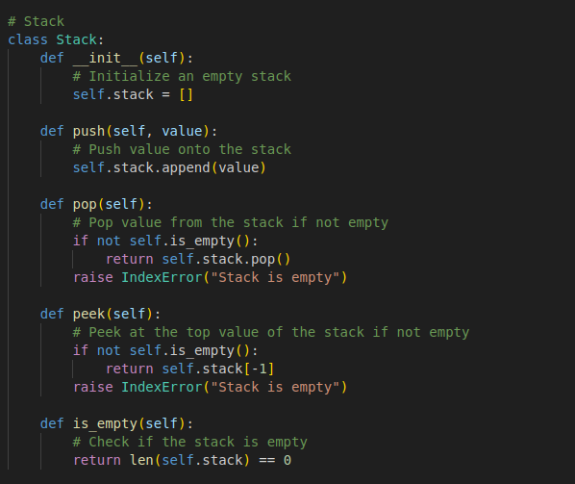

### **Queue**

A queue is structured around the First-In-First-Out (FIFO) method, ensuring that elements are removed in the same order they were added. The implemented queue supports enqueueing elements at the end, dequeueing from the front, and peeking at the front element. Queues are efficient for task scheduling, message handling, and other sequential operations, with all major operations having O(1) time complexity.

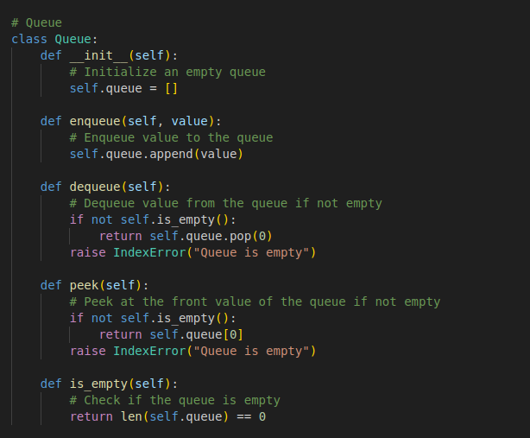

### **Linked List**

A linked list is a flexible data structure consisting of nodes, with each node holding a data value and a reference to the next node in the sequence. The singly linked list implementation supports insertion at the end, deletion of a specific value, and traversal of all nodes. While linked lists lack random access, they excel in dynamic memory allocation and efficient insertion/deletion.

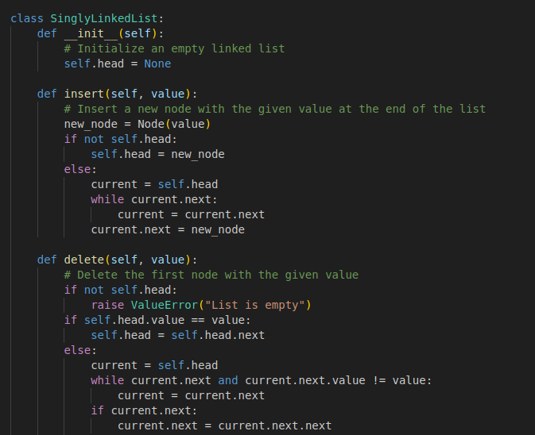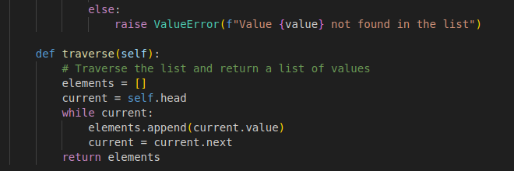

## **Performance Analysis**

The performance of each data structure varies depending on the operation and use case. Arrays provide constant time O(1) access to elements via indexing, but insertion and deletion can be costly O(n) due to the need to shift elements. Linked lists, on the other hand, have O(1) insertion and deletion when operating at the head, but accessing elements requires traversal, resulting in O(n) complexity.

Stacks and queues are fundamental yet highly effective data structures. When implemented with arrays, they offer constant time operations like push, pop, enqueue, and dequeue. However, using linked lists for these structures can provide flexibility in terms of dynamic size but introduces additional memory overhead for node pointers.

Trade-offs exist between memory usage and performance. Arrays are ideal when a fixed size is acceptable and indexed access is required. Linked lists are preferable when dynamic resizing is needed, especially in applications with frequent insertions or deletions.

## **Practical Applications**

Arrays are widely used in scenarios such as storing tabular data, implementing matrices for computational tasks, and indexing for fast lookups. They are fundamental to more complex data structures like hash tables and heaps. Stacks find their utility in backtracking algorithms, expression parsing, and managing function calls in recursion. Their ability to efficiently handle a sequence of operations in reverse order makes them indispensable in many software systems.

Queues play a crucial role in scheduling tasks, managing workflows, and handling asynchronous events in systems like message queues and CPU task scheduling. They are also pivotal in algorithms such as Breadth-First Search (BFS) in graph theory. Linked lists are essential in applications where dynamic memory management is necessary. They are commonly used in real-time systems, graph representations (adjacency lists), and in designing other advanced data structures like trees.

## **Code and Results**

The Python implementation demonstrates all the discussed data structures. The testing process uses unique values to showcase their functionality and operations.

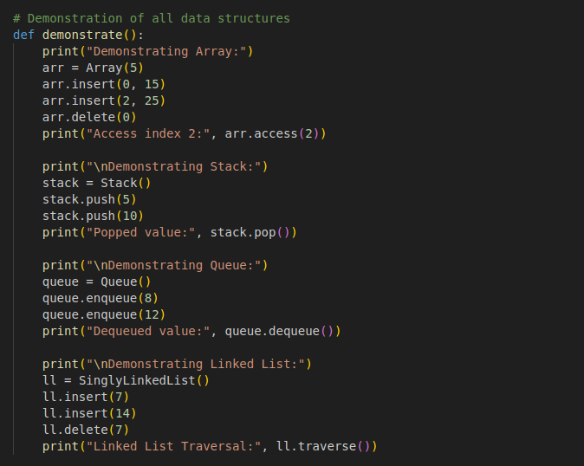

### **Array**

Testing the array involved inserting values at specific indices, deleting a value, and accessing an element. The output confirms successful operations:



### **Stack**

The stack was tested by pushing two values onto the stack, popping the last added value, and confirming that the operations were executed correctly:



### **Queue**

The queue was tested by enqueueing two elements, dequeuing one, and confirming the FIFO behavior:



### **Linked List**

The linked list was tested by inserting two values, deleting one, and traversing the remaining nodes. The traversal confirms the expected results:



## **Conclusion**

This report illustrates the design, implementation, and analysis of arrays, stacks, queues, and linked lists. Arrays are efficient for indexed data manipulation, but their fixed size makes them less flexible. Stacks and queues provide specialized behavior that simplifies problems like backtracking, task scheduling, and graph traversal. Linked lists, with their dynamic memory allocation, are invaluable in situations requiring frequent updates and flexibility.

By understanding these structures, developers can select the best option based on factors like memory efficiency, speed, and ease of implementation. Mastery of these fundamental concepts is essential for tackling more complex problems in computer science and software development.

**References**

Bhadange, S. (2021, December 14). Implementing Arrays with python - SURAJ BHADANGE - Medium. *Medium*. <https://medium.com/@bsurajbh/implementing-arrays-with-python-7586206f0b13>

Cormen, T. H., Leiserson, C. E., Rivest, R. L., & Stein, C. (2022). *Introduction to Algorithms, fourth edition*. MIT Press.

GeeksforGeeks. (2024, June 20). *Stack in Python*. GeeksforGeeks. <https://www.geeksforgeeks.org/stack-in-python/>

Gicheha, K. (2023, December 20). Implementing a singly linked list in Python - Kevin Gicheha - Medium. *Medium*. <https://medium.com/@gichehakevin/implementing-a-singly-linked-list-with-python-41d38b6d6131>

*Queue in Python - Javatpoint*. (n.d.). www.javatpoint.com. <https://www.javatpoint.com/queue-in-python>